DATE: | January 21, 2025
TO: | LaTanya Bellow, City Manager
FROM: | April Richardson, City Clerk
SUBJECT: | Resolution Of The City Council Of The City Of Emeryville Appointing Standby Officers For City Council Member Succession In The Event Of A Declared Emergency For Calendar Year 2025

Recommendation
Staff recommends that the City Council approve the above-entitled Resolution to appoint standby officers for City Council Member succession for Calendar Year 2025 in the event of a declared emergency.

Background
The City Council’s role during an emergency or disaster is to provide continuity of government through effective leadership, authority, and policy direction on emergency and recovery operations. A major disaster could destroy the ability of the City Council to carry out these functions if a quorum of the City Council cannot be established.

Government Code Sections 8635-8644 provide the authority for local governments to reconstitute themselves in the event that incumbent elected officials are unable or unavailable to serve due to either being missing, killed, or seriously injured enough to be unable to perform their City Council duties due to a state of emergency. In the event of a declared emergency, members of the City Council shall fill vacancies from the appropriated list of standby officers until there are sufficient officers available to constitute a quorum. In the event that there is only one member of the governing body or one standby officer, that one member shall have the power to reconstitute the City Council.

Discussion
The City Council may appoint standby officers by resolution to serve in the members’ place in the event members are unavailable. Government Code Section 8638 authorizes the City Council to appoint three standby officers for each member, and to designate them as first, second and third choices, as the case may be.

Government Code Section 8639 provides that local governments should consider places of residence and work for each appointed standby officer to ensure the greatest probability of survivorship and availability. In addition, standby officers may be residents or officers of another political subdivision. Suggested minimum qualifications include that they must be a City resident, over 18 years of age, and a registered voter, with additional criteria that they have familiarity with City operations and/or experience having served on the City Council and/or a City commission or committee.

Once appointed, the standby officers would be administered the oath of office, would serve at the pleasure of the City Council, and could be removed and replaced at any time with or without cause. Reappointment of existing standby officers or appointment of new ones is to occur annually. The terms of these appointments shall be for one year.

Staff requested the City Council contact their current standby officers to inquire whether they are interested in being reappointed. Council Members may either reappoint those appointees or nominate up to three different standby officers from among qualified people they have personally identified.

Emeryville Municipal Code section 4-2.08(b) provides that the City Manager, in their role as the Director of Emergency Services, shall designate the order of succession. The City Manager will also appoint standby officers as follows: 1) Community Services Director, 2) Public Works Director, and 3) Community Development Director. No City Council direction is requested on these appointments.

Fiscal Impact
There is no fiscal impact.

Staff Communication with the Public
Staff have not had any communication with the public regarding this matter.

PREPARED BY: Lorrayne Leong, Deputy City Clerk

Approved and Forwarded to the
City Council of the City of Emeryville:
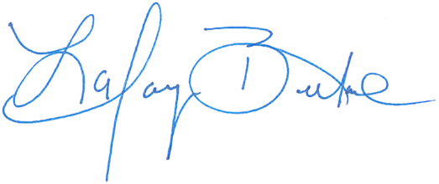
LaTanya Bellow, City Manager

Attachments
- Attachment A – 2024 City Council Emergency Standby Officers Roster
- Attachment B – Government Code Sections 8635-8644
- Draft Resolution
  - Exhibit A – 2025 City Council Emergency Standby Officers Roster

Government Code §§8638 and 8643(b).
§8643(b).
Government Code §8638.
Government Code §8638(b).
Government Code §8640.

