DATE: | January 21, 2025
TO: | Adam Politzer, Interim City Manager
FROM: | Lilybell Nakamura, Acting Finance Director
SUBJECT: | Warrants

Attached are the following items for City Council approval at the meeting of January 21, 2025:

- Wire Transfers and Debit Authorizations for November 20, 2024, through December 31, 2024 in the amount of $2,356,498.91

- Warrant Register for the City of Emeryville dated December 31, 2024, in the amount of $3,091,465.13

I certify that the above-stated demands are accurate, and funds are available for payment thereof.

Approved and Forwarded to the
City Council of the City of Emeryville:
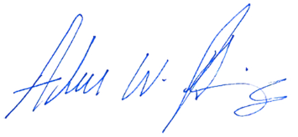
Adam Politzer, Interim City Manager

