DATE: | January 21, 2025
TO: | Adam Politzer, Interim Executive Director
FROM: | Lilybell Nakamura, Acting Finance Director
SUBJECT: | Warrants

Attached are the following items for Successor Agency approval at the meeting of January 21, 2025:

- No Wire Transfers and Debit Authorizations for November 20, 2024, through December 31, 2024.

- Warrant Register for the City of Emeryville as Successor Agency to the Emeryville Redevelopment Agency dated December 31, 2024, in the amount of $3,989,308.31.

I certify that the above-stated demands are accurate, and funds are available for payment thereof.

Approved and Forwarded to the
City Council of the City of Emeryville as Successor Agency to the Emeryville Redevelopment Agency:
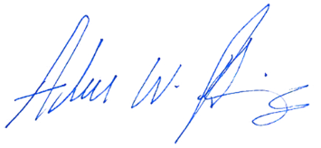
Adam Politzer, Interim Executive Director

