DATE: | January 21, 2025
TO: | LaTanya Bellow, City Manager
FROM: | April Richardson, City Clerk
SUBJECT: | Resolution Of The City Council Of The City Of Emeryville Appointing City Council Representatives To Various County, Regional And Statewide Boards, Commissions And Committees For One-Year Terms Unless Otherwise Noted; Publicly Noticing FPPC Form Number 806 As Required By FPPC Regulation 18705.5; And Amending The 2025 City Roster Of County, Regional And Statewide Bodies Accordingly

Recommendation
Staff recommends that the City Council adopt the above-entitled Resolution appointing City representatives to the various county, regional and statewide boards, commissions and committees for one-year terms unless otherwise noted.

Background
Each year following City Council reorganization, the City Council appoints City representatives to various county, regional and statewide bodies (“regional bodies”). For some of these positions, the representative receives a stipend from the regional bodies as compensation for their attendance at meetings. The City Council thereby adopted Resolution No. 12-146:

“Resolution of the City Council of the City of Emeryville Relating to Appointment of Councilmembers to Compensated Positions and Directing the City Clerk to Post Form 806 as Required by FPPC Regulation 18705.5”.

Accordingly, all Council Members may participate in a decision to appoint representatives to a compensated position. The City Clerk will subsequently publicly notice the completed FPPC Form No. 806 on the City’s website.

Discussion
Staff recommends that the City Council appoint members of its body to the various county, regional and statewide boards, commissions, and committees for one-year terms, or until such persons are replaced or their commissions expire. Attached to the staff report is the 2025 City Roster for Council Members for reference. Upon City Council appointment, the City Clerk’s Office will amend the 2025 City Roster of County, Regional and Statewide Bodies accordingly.

Fiscal Impact
There is no fiscal impact.

Staff Communication with the Public
Staff have not had any communication with the public regarding this matter.

PREPARED BY: Lorrayne Leong, Deputy City Clerk

Approved and Forwarded to the
City Council of the City of Emeryville:
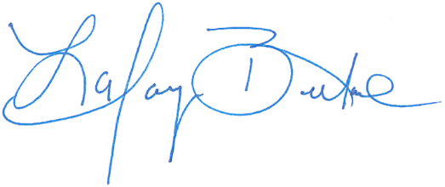
LaTanya Bellow, City Manager

Attachments
- Draft Resolution
  - Exhibit A – 2025 City Roster of County, Regional and Statewide Bodies
  - Exhibit B – 2025 FPPC Form 806

